Annual Report 2011 - 2012
REHABILITATION

It has been another good year for the PCTC Rehabilitation Team, thanks to the continued support of staff, children, parents and donors.

I. Early Detection activity:
Through our Continues effort a pilot study on early detection and intervention of disability in children conducted in coordination with Directorate of Differently Abled Welfare. The study was conducted among the children in the 0-6 age group. We took up the pilot study With the help of welfare workers and screened 7642 children in the block. We carried out door to review for all these children and short listed 180 children with traces of developmental delay for further screening .Finally as many as 141 children in the 0-6 age group including previously identified children were found to have various forms of disability. The consolidated Needs of 141 Children are
Needs | Np of persons
ID cards | 58
Regular Therapy | 18
Early Intervention | 77
Assistive Devices | 14
Review with Experts | 14
Special School Admission | 4
Special Education | 13
Surgery 2 | 2
Epleptic treatment 5 | 5
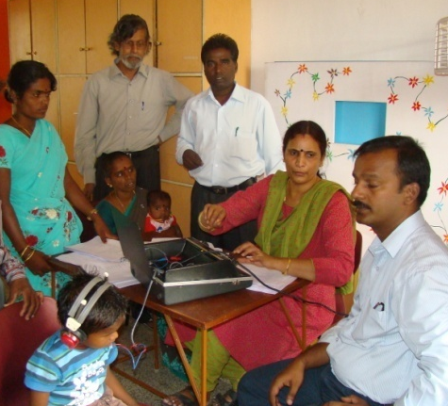

II. Early Intervention activity:

Those who showed signs of delayed development were invited to attend our Early Intervention clinics in the Kariyandal and Nookkambadi centers. In all of the 29 children who attended, we observed remarkable improvements in the following areas:

- General health and seizers (fits)
- Physical development (Such as Head lag, Sitting rolling crawling ,standing ,gait activities
- Cognitive development (more emphasis will be placed on this in the coming months)
- The attitude of the parents (positive approach towards their child abilities, Practicing the prescribed interventions at home such as therapy ,Assistive Devices ,Medicine Etc)
- The ability of the parents to handle their children effectively (carrying the children safely etc.)

We provided each child with the specific Physical Development Aids such as seating devices, gaiters and splints ,Rolaters and modified Rolaters they required. Through frequent house visits made to support the parents and also in house adaption activities. First time this year parents join their hands in fabricating seating devices with volunteers.

III. Parent Training activity:

The aim of this activity is to teach parents how to care for their differently able children .At the beginning of the year we devised a strategy for how best to support each child and grouped them according to their needs. At the beginning of the year 70 children were involved in this activity, and 31 more were identified and among them 22 are integrated later. For various reasons, a total of 18 children dropped out of the project before the end of the year. The Parent Training Activity focused in these aspects:
Intervention | N0.of children
Therapeutic intervention - 37 | 37
General health - 92 | 92
Physical Development Aids -13 | 13
Functional Literacy - 19 | 19
Daily Living Skills – 36 | 36
Pre - Vocational Skills – 9 | 9
Addressing behavioral issues – 5 | 5
Communication Skills – 28 | 28
House adaption activity -4 | 4

- This year, a total of 3 families finished the Parent Training Program (due to the children turning 18), but PCTC continues to support them.
- To make aware of their children problems and potentials monthly one case study was introduced..
- Trained them in native medicine for simple remedies health tonics and massage oil for their children.
- Systematic fits management program developed for 4 children
- Acupressure therapy was introduced for 27 children for specific problems (such as drooling, urine and bowel control, respiratory problems etc
- Seasonal Herbal food preparation introduced for parents at monthly once.

IV. Day Care Center:

One of the principle activities in our Rehabilitation program is the Day Care Center (DCC), which provides motivation and support for children in the Early Intervention and Parent Training activities in both our Kariyandal and Nookkambadi centers. At the beginning of the year we had 17 children in the Kariyandal center, which was stable till the end(Two children inducted and two relieved). At Nookkambadi, we began with 15 children and finished the year with 15 children. (Similar situation as mentioned for kariyandal 3 children relieved and 3 inducted) For next year we decided to extended transport facilities to few more remote villages
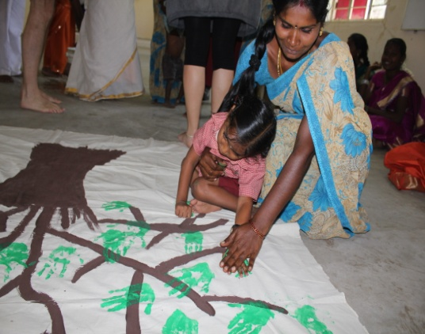
Intervention | N0.of children
Physical Therapy | 20
SPL education | 26
ADLS Training | 26
Communication Skills | 21
Developmental aids | 8
Medical treatment | 31
Seizure treatment | 4
Extra training for specific behavioral issues | 6
House adaption activity | 4
Treatment for drooling | 2
house adaptation activities | 3

Every day we provide children with supplement food to help them gain weight, and monthly home visits ensure that adequate care is being provided by the parents. Every month we organize a meeting and training session for the parents involved.

Several of our children participated in World Differently Able Day in early December, performing a dance which they had been working on. On the 31st of December we celebrated Makkal Thiruvizha: several children performed a dance, sports activities were provided gifts to all children and parents.

Over the course of the year many volunteers from various countries have spent time at PCTC, and they have contributed noticeably to the progress of our children. A get-together was organized by them for our DCC and VT students and provide opportunities’ to explore their potentials.

V. Vocational Training:

Even the most talented differently-able children are struggling once they leave education, due to prejudices and lack of awareness among parents and communities. To combat this, we have been running vocational training activities in both of our centers. A total of 27 children have been involved in this activity and 6 children’s, were dropped in the middle, and the activities include:

Sewing and tailoring – 8 ; Envelope making - 1; Making of food bags - 2 ;Petty shop training 1; Manure composting 5; Center maintenance & Gardening Cattle and sheep raring 9.

Additional activities include: Functional literacy; Daily living skills; Life education skills
Leisure activities
The parents play an active role in identifying a suitable trade for their children to be trained in. Monthly meetings are held with parents to evaluate the progress of their children.
PCTC has links with several local employers, and we hope to send many of our children to them once they finish their Training.
7 of our pre vocational students who got trained in tailoring were employed in the garment unit.

VI. Staff Training:

The roles and responsibilities of each member of staff are clarified and discussed regularly. Every month, the achievements of each member of staff are discussed and compared to their initial targets. Weekly and monthly review sessions are held for all staff. The third Saturday of every month is reserved for staff training in which each member of staff presents a case study of one child. One day training organized on acupressure Half yearly review was done and based on the findings the action plan was modified. Training on child specific teaching and learning material preparation. Specific training given in vision building Exercies,Physical Therapy Exercises

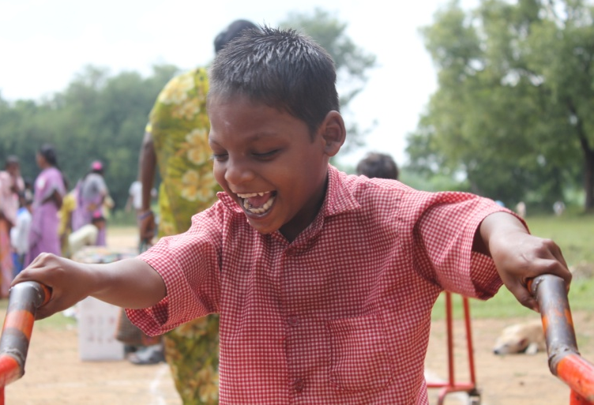
CBR Activities:

This year, we raised our standard in data maintaince. PCTC played a key role in developing new software for data maintenance in coordination with District Differently Able welfare office. we assisted 57 new PWDS to get national ID cards and 30 PWD’s who are already certified was identified (person with disability) in the area. One welfare worker, who will carry out CBR work, has been provided in each of the 47 panchayats. (This has been suspended from april -2011 to march 2012). PCTC has collaborated with the Leprosy Mission Trust India to identify and support leprosy affected persons in the area. Awareness has been raised of the local Primary Health Center and the benefits that it can offer to these people in the area. 3 –Medical camp were organized in which 22 persons were provided Ulcer treatment and MCR sandals.
In 10 selected Village level federation was formed for differently able people. With the help of village level federation we are able to form Block level federation and we motive the PWDs to strengthen their federation.

An article was published in “The Hindu” newspaper about ‘Early Detection to check disability among children. School visits have been made, providing academic Special education to children in the 6 to14 age range. 67 were encouraged to apply for government educational grants, of which57 were
successful. Another camp was organized to provide children with developmental aids: a total of 61 children benefited. Primary work done to start village level Parent Training in Boothamangalam panchayats:

Applications for free bus passes were sent to the government: 18 PWD’s benefited. Many of the beneficiaries use their bus passes to travel to work and to PCTC’s vocational unit and DCC
5 hearing aid was applied for and received.
14 hand operated tricycles were provided to local people.
2 Wheel chair
2 Artificial limb
2 Caliper
5 Auxiliary Crutch
5 Folding stick ,Gaggles, Braile watch

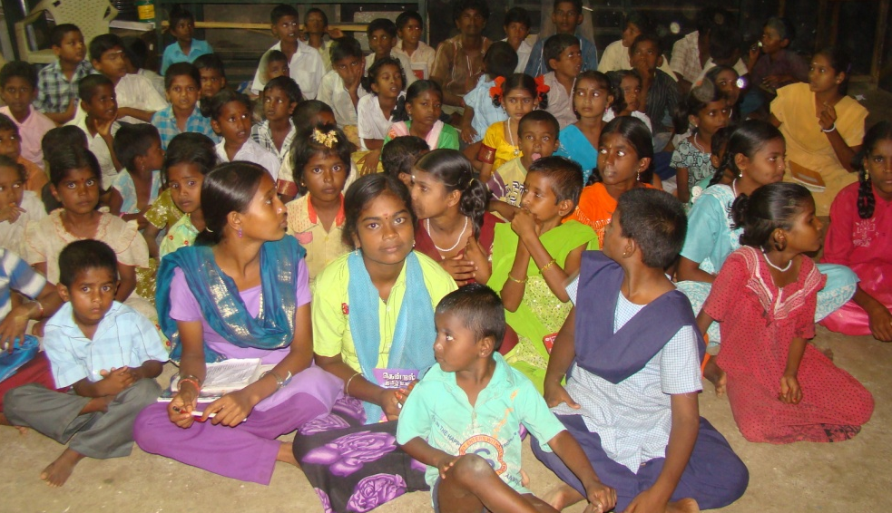
THULIR with its entry into the fourth year of its functioning added six new centres into its fold. At present there are 300 registered children with Thulir and more than 50 unregistered children in 11 panchayats of the Thurinjapuram block. The reason for unregistered children is that they join these centres later after getting motivation and seeing good responses and wide activities of these centres.
Thulir aims at providing skills to the rural youth in the field of education and art. It also covers other aspects in accordance with holistic development of youth and the community such as personal health, community health, environment, social awareness and Community based Rehabilitation activities for differently abled persons. Thulir children are highly talented in various forms of arts such as painting, singing, oratory, writing, Kolam and sports etc.

In the year 2011 -2012 training programs for the teachers as well as for the children were organized on a monthly basis. Input sessions were held in every monthly meetings. The details are given below:

Input sessions for teachers:
Right To Information Act. Adolescent health and prevention of Anemia Health and hygiene Disadvantages of excessive use of cell phones benefits of Siddha medicine. The input sessions were given to Teachers in Monthly meeting in the form of group discussions, role play and debate etc. charts, books and information materials are provided to the teachers in every session. The input sessions are conducted with full involvement of the teachers where each and every one is given equal chance for viewing their opinions and sharing.
Thulir Monthly Meeting……
The meeting begins with the submission of the previous month’s business and followed by the evaluation of the reports. It takes more than an hour in evaluating the report. Then it would be a session for the discussion of the problems faced by different Thulir cen tre’s. Here the teachers put forward their problems and leading to a discussion, where all share and give opinions to tackle the problem. The next session would be showcasing the children’s talents where the children show their talents in the form of dance, singing, speech, telling stories and jokes, mimicry and yoga etc. The teachers also never give up a chance in showcasing their talents and stay active in doing so. This will be followed by group activities for the children where the children are divided into two groups and the topics are given to each group for the group presentation. This helps the children to adjust to the new environment and helps them to contribute to the group with mutual cooperation. After this a discussion is activated to discuss the performance of each group. This will be followed by lunch break and after the lunch session, there would be an input session for the teachers. After the input session, the syllabus for the next month will be covered and activities for the next month will be done. The meeting will be concluded with the distribution of the previous month’s salary.

Independence Day celebrations:
Marking the Independence Day on 15th Aug, children were given chance to showcase their talents in the form of singing, dance, poetry and skits to the village. From the reports given by the teachers it was revealed that large number of village people turned up to view the program and the appreciated the children for their presentation. There were instances that many non Thulir children were showing eager to join Thulir movement following the talented presentations. Prizes were distributed to the winners of the competitions and also for the participants by the respective teachers.
Thulir monthly meeting schedule
Report evaluation
Discussion on the issues
Talent showcase by Children, Teachers
Group activity for the children
Lunch break
Input session
Covering syllabus and planning for next month
Distribution of salary

Rise and fall of Narthampoondi:
Narthampoondi Thulir centre was filled with uncertainties and confusion due to the poor attendance and lack of cooperation from the parents. There were just five children sitting along with the teacher and one or two peeping out the centre. This proved to be disappointing one and posed question on the need of this centre. The teacher was also disappointed due to this and there was common view on resolving this crisis at the earliest.

There was yet another visit to the centre after a week, where one found that the number of children coming to the centre was slightly better than the previous visit but still it was an issue to be sorted out. Following this the village youth, who was part of Thulir movement were called and were asked to give option on what has to be done with the centre in the future. The youth in one voice replied that they will take charge of the situation and Plan out parents meeting for convincing the parents and improving the attendance in the centre. This assurance from the youth made us feel confidence than ever before but still was not sure of the exact outcome.

On the proposed day of parents meeting it was shocking to see no parents turned up for the meeting; instead it let us to surprise in noting that 26 children were present in the centre. This was found to be a huge change of attitude of parents as well as the children in considering the centre for their own benefit and need. Here the role of the village youth is to be appreciated and without them the positive change wouldn’t have been achieved.

The centre which transformed itself to be one of the busy and aspiring position got jolt after three months of its successive functioning in July 2011. This time the crisis loomed in the form of teacher unable to continue the classes as she was getting married on the later of the month. This posed yet another challenge for the survival of the centre. The teacher herself understood the problem and decided to take classes till her wedding on Early Nov. The teacher also suggested few persons to take charge of her position and following this there were number of meetings with the village youth, SHG’s , ward member and the Panchayat president. There were different level of matters arising out the meetings but there were no clear conclusion and decision was made as each one had different sets of stories and views. The youth once been a savior for the centre were found to be not interested in taking charge of the situation. On the other hand the SHG’s just ignoring the topic and in chorus ended up telling us that “your decision is our decision”. In the mean time the panchayat president who was giving us full assurances and cooperation in the beginning was on a back foot stating the reason to be community problem. There were many persons who promised to take charge as teacher but finally disappointed by staying out of it. The lack of cooperation at all levels and wastage of time and energy forced us take a bitter decision to wrap up the centre in Narthampoondi.

Mangalam Putting brave heart:
Mangalam Thulir centre know for its extra curricular activities and two times Thulir champions in Makkal Thiruviza was put to test in the form of power disconnection to the centre. The centre was temporarily put on hold for more than 2 months due the power problem. The teacher and the students showed keen interest and full commitment in solving the crisis in order to have the Thulir centre on the track. In this, the role of the teacher needs to be appreciated for putting a brave front in resolving the problem. Mrs. Rani, the Thulir teacher of Mangalam kept landing up in the EB office and petitioned the officials regarding this. The teacher was in no mood to accept the assurances given by the officials over two months and finally went to the extent of threatening the officials by taking up the issue to the district collector. Following this, on the same day the connection was given to the centre and the centre resumed functioning from 8th August 2011.

Unfinished task in M.N.Palayam
M.N.Palyam was suggested to be one of the potential village to start new Thulir centre showed different level of experiences. The planning out process started on the mid Aug for the inauguration which was planned to be in early Nov. There was much hope with the centre as there were all procedures completed except taking up charge of electrical bill. The PLF in charge of the village showed full interest in dealing with the situation by taking up the issue in the village meeting in Sept. The person later confessed that the serious political situation and campaigning by candidates due to Local body election forced her not to take up the issue in the village. The PLF added that anything regarding this issue can be handled only after the elections and assured that the new centre will be inaugurated on the planned date. Soon after the polls, appointment was sought to meet the president and the president too agreed to the date and promised to take charge of the electric bill of the centre and the connection will be given in two days. After two days it was found that the hope and assurances was mere gimmick and the inauguration of new centre in M.N.Palayam was unfinished.

A new hope in Kalasthambadi
With the few days left for the inauguration of new centres and the disappointment from M.N.Palayam, it was mandatory to finish up the task of inaugurating new centre. There was busy and challenge task was found ahead without any option but to succeed with a new centre. It was indeed challenging task and more over much of excitement was involved in it. The new centre was identified to be Kalasthambadi and the ground works were been carried out in great speed involving number of interactions with the community.
The Thulir student’s movement was successfully inaugurated in Kalasthambadi panchayat on 8th Nov 2011 at 6 P.m. Kalasthambadi panchayat is situated in an equable distance from Thurinjapuram as well as from Madalampadi and it is 10 Kms away from Kondam. This panchayat has the total population of 1350 including the SC and BC communities who are mostly agriculture workers and daily laborers. This was the twelfth centre to be inaugurated by PCTC of this kind following Boothamangalam panchayat in Thurinjapuram block. The centre was inaugurated in the presence of village people, village president, officials and guests from People’s Craft Training Centre, Kondam.
The centre was started with 34 children and many more children eager to join the centre in the coming days. The centre can accommodate children from 6-12th class but due to unavailability of higher secondary school, only children from class 6-8th are registered to the centre in this village.

The welcome address was given by Mr. Peraman (ward member). Then as a mark of new beginning and hope the light was lit by one representative from village, two students, centre teacher and a guest lighted the lamp and inaugurated the program. It was followed by special address by the village people. Then Mr.Xavier Mariadoss, Program director (PCTC) shared the importance and need of Thulir Movement in the village as well as highlighted that the village should consider that this is their own program and the success of the program lies with the cooperation of the people. After his motivating talk, there was song presented by Thulir children regarding the need of savings. This was followed by entertainment dance by Mangalam Thulir children which were enjoyed by the audiences especially the guests from abroad. The inauguration program was carried on by the address of the Panchayat president Mr. Ranganathan, distribution of ID Cards. There was a breath taking talk by Nirosha a Thulir student from Mangalam and finally the program was closed with vote of thanks by the Thulir teacher thanking the public, representatives from various groups and the officials for their valuable presence and making the program a tremendous success.

MAKKAL THIRUVIZA 2011 PLANNING

The planning process for the Makkal Thiruviza began on 30th Oct in the monthly meeting which was chaired by the program director, PCTC. Here the list of the competitions were discussed and finalaized. Thulir teachers were given a month time to prepare the name list of the participants for various competitions. The meeting was followed by another meeting for the PLF Secretaries on 11th Nov.

MAKKAL THIRUVIZA

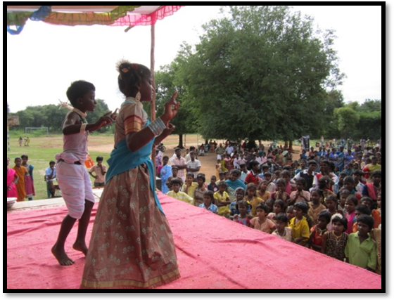
Makkal Thiruviza an annual feast of PCTC, which is celebrated with the huge community participation, includes the SHG, Thulir movement and differently abled persons. The jubilant community event for the year was held in Vedanthavadi. At 9am the program was inaugurated by the Head master of Vedanthavadi higher sec school by hoisting the flag. The event gained momentum with the kolam competition for the SHG’s where the ladies left no time to showcase the talents and with full enthusiasm decorated the whole ground with colorful kolam. The Thulir children in no time captured the attention of the audiences by exciting kabadi game. With the event in the full swing the chief guest for the event Mr.Aranganathan (MLA) arrived to the occasion and the greeted the public as well as the children. There was special dance called “Karragattam” performed for the chief guest by the Mangalam Thulir children who received overwhelming appreciation by the audience. Simultaneously other competitions like Herbal exhibition, Village research, Kolam, Koko and events for differently abled children engaged the audiences in full spirit with prizes beingdistributed after the events. The occasion was filled surprises by the backing up of Former staffs of PCTC, who turned up in large numbers and participated in the occasion. This in one way symbolizes their relationship and solidarity with the NGO.
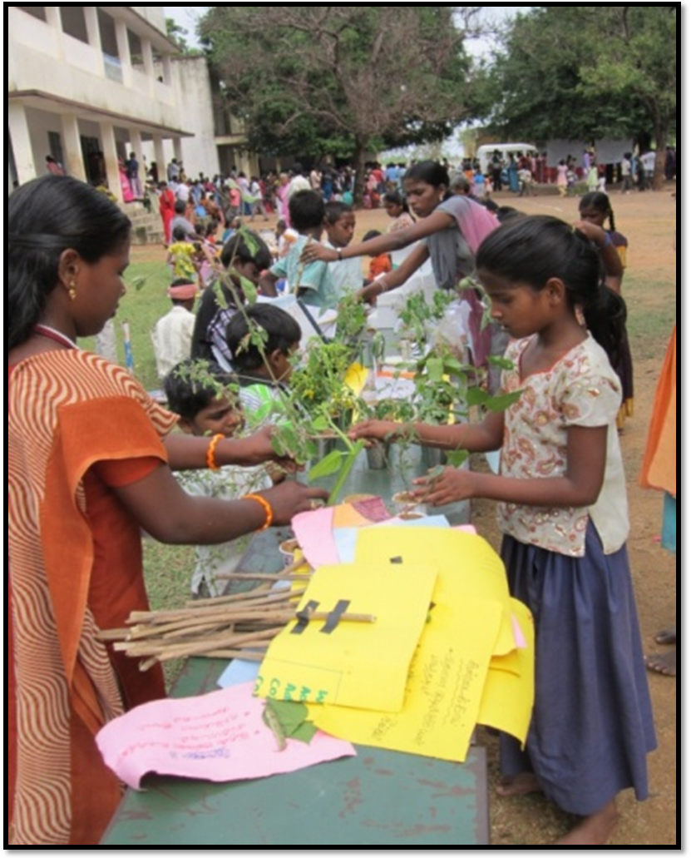
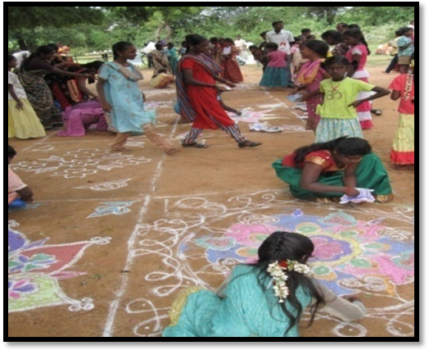
The most awaited champion Trophy for Thulir 2011-2012 was bagged by Mangalam by 120 points which stood the majestic chart ahead of 30 points leaving Ved-1 unparalleled. Makkal Thiruviza 2011 which was filled with uncertainty a day ago leaving the orginizers and the participants in confusion was simply magical and proved to be a successful and memorable one and which succeeded in giving a take home message “ Hard work never fails”.
Session on Adolescent health and prevention of Anemia
This was a session meant for adolescent health and prevention of anemia. Here the staffs were introduced to a condition called anemia and its causes among adolescent girl children. The staffs were given books on anemia prevention where all the relevant information such as the causes, symptoms and the ways to prevent and also the ways to treat was given.
The staffs were asked to conduct a session on this regard to the adolescent girls in their respective villages.

Conclusion

As usual The Rehabilitation program had its course correction throughout the year as and when we face difficulties. The impact of our intervention could be seen in the program as we are getting very young children for intervention. As plan for next year the thrust area would be to bring more quality into our intervention… and flexibility in our intervention in terms of timing and place of intervention.

Thulir being one of the major projects of the Organization, which involves wide range of activities, is always filled with round the clock segments of excitement and challenges. This can be proved with number of instances tempted various NGO‘s to take up similar programs and also going to an extent of luring the groups to support the programs of their own. This testimony the existing nature and the reservoir of strength possessed by Thulir student’s movement and the work carried out by it.

We thank all our supporters and well wishes for their continued support- enabling us to provide continuous service in this area




